February 2018 Newsletter
St. Peter Catholic School
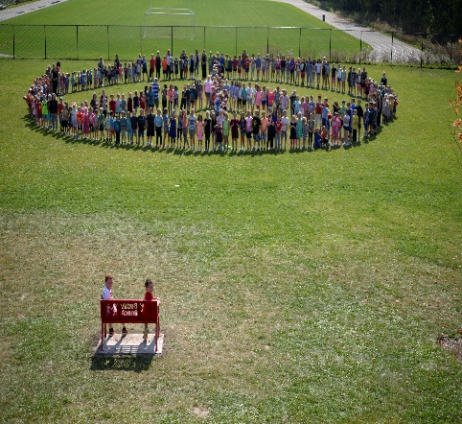

Upcoming Events

February 2
PA Day
February 8
Family Dance & Dinner
February 14
Ash Wednesday Mass at 9

February 20
Report cards & IEPs go home

February 20
Parent Council Meeting 6 pm

February 22
Parent Teacher Interviews
From the Parish
St. Peter Special School Mass and Social – March 4th at the 9 am mass
February 24/25 – Confirmation Enrollment
March 3/4 – First Communion Enrollment (during regular mass times)

Serve Well, Bring Hope, Celebrate All
http://schools.alcdsb.on.ca/pett/default.aspx
613-392-6577 Follow us on Twitter: @St_Peter_CES
In January, the Catholic Church celebrated the Month of the Holy Name of Jesus; and in February, we turn to the entire Holy Family—Jesus, Mary, and Joseph. In sending His Son to earth as a Baby, born into a family, God elevated the family beyond a mere natural institution.
Our own family life reflects that lived by Christ, in obedience to His mother and foster father. Both as children and as parents, we can take comfort in the fact that we have the perfect model of the family before us in the Holy Family.

Why is School Attendance Important from an Early Age
The Provincial School Attendance Counsellor defines 'persistent absenteeism' as "any student who has missed 10% or more of school days for any reason, including unexcused or excused absences, over an academic year”.
Ontario elementary schools have 194 days of instruction for students. A student who misses 19 days of school is deemed persistently absent. Statistics show that persistent absenteeism puts children's future success at risk.

Early school absenteeism is an indicator of future school absenteeism.

Absenteeism in kindergarten negatively affects a child’s ability to develop the grit and perseverance needed for academic success.

Absenteeism has a significant effect on a child’s ability to learn/master reading.
Please see http://www.sncdsb.on.ca/blog/5-things-you-must-know-about-school-attendance for more information.

Safety First– Absences, Late Arrival and Early Pick up

Parent Councils play a vital role in the education system in Ontario. They provide a forum through which parents and members of school communities can contribute to improving student achievement and school performance. Thank you to all those who play a role on our Parent Council! If you are interested in learning more or on how to join, please contact the school.
We will be hosting an Olympic Spirit Week February 12-16th – stay tune for more information of the week’s events!

Virtue of the Month
As a student of St. Peter School, I will use my voice so that I can live my life like Jesus.
- I will honour God’s gift of life
- I will treat others fairly
- I will make decisions that benefit our community

Our main priority is keeping all kids safe! Our Safe Arrival program is in place to ensure that we always know arrival and departure information about all children. Please call the school before 8 am to report absences or changes to the daily routine - 613 392 6577 or email at flhppett@alcdsb.on.ca. In addition, if you pick up your child early without notice, it disrupts learning and is difficult for the teachers and students as they prepare for the end of the day.
Some teachers may be using other means of communication such as RemindApp - however this is not to be used as a replacement for calls or emails to the office. Thank you! #SafetyFirst
Wellness and Supports Available
